**News Website Project Report**

**Bhasker:1602-19-735-005**

**Shaik Arif:1602-19-735-042**

**Shravani:1602-19-735-046**

**ABSTARCT:**

News is that part of communication that keeps us informed of the changing events, issues and characters in the outside world. The world is going to be more digital, and digitalization is the need of every business, every industry. An Online portal plays a vital role in educating and informing people with latest updates, current happenings around the globe. In this busy world people do not have much time to spend on reading a printed newspaper with yesterday’s happenings so they need to be updated with latest news at an instant. Many websites of individual newspapers offer news but are centralized over the articles and authors of a limited set of people that is the respective parent website. Our website overcomes this by providing you articles and news coverages all over the internet collectively at one site. The other major problem that is resolved is many websites give personalized news which limits the user’s knowledge. Whereas this project gives the users news articles fetched directly from news api which gives users non personalized news. This website gives user easier accessibility, fastest and latest news updates minute to minute.

**Contents**

Chapter 1: Introduction

Chapter 2: Block diagram and Literature

Chapter 3: Implementation details and literature

Chapter 4: Results and Discussion

Chapter 5: References and Biblography

**Introduction**

News is information about current events. At present information is the most valuable resource of the current world. This may be provided by different media. A printed newspaper has been in common use since ages. But in today’s world people do not have much patience to study the news articles and newspapers which are printed with news of a day before which is very outdated with present digital revolution. People need to be updated with time-to-time minute to minute fresh and updated news. This is possible by online media which gives information at the tip of the fingers with just one click away.

The objective of this project is to provide daily news and breaking news at any instant of time. Anytime, anywhere, anyone can know about the news or information by internet at low cost. This website can show a variety of news articles, breaking news updated at the exact instant. This website gives a broader and wider range of articles covering all the news organisation all over India. Unlike, the news webpages of news organizations which provide us with very limited news and articles that is which are confines to the authors and news articles of their website.

Our website provides with the collection of various articles over the internet. This provides with news coverages from all over India providing with collection of various articles and authors brought down to a single page. This website also provides with a non-personalized results for any user. That is almost every website today has this personalized results or services for users to take more interest of a user to spend time on their domain. Whereas our website provides news coverages without considering these aspects as we get news directly from the news api. There is no filtering or personalizing of news to a user which would limit the coverage of news to a user. This is useful because there are many cases where a user is not intimidated with some important or meaning full searches not presented to just as it’s would not interest a user. They are refreshed with the same topics over and over and there is no break to it. Amidst this many people are looking forward to such websites which give us a non-personalized news. This is the case where our website can help out as we have the news directly without a filter which is solely based on the popularity as a whole but not individually.

News is reflected automatically as information is retrieved with the help of NEWS API. This website provides you with the top news updated at the very instant. It also gives us some categorized news on various categories. These include top news of Business, Health, Sports, Entertainment, Science, Technology. Each category news is updated to the user with a click. News of every category are displayed which are updated to the very moment. This website also provides with a basic search bar. This gives news articles about a topic of anything of a user’s interest.

This website offers information to the public, political, social, sports, health, entertainment etc. This portal provides with Instant and latest news from all over the world with easier accessibility. People can access and use with much ease. It gives you with fastest and Latest news updates as per the interest of category or just the top breaking news. Breaking News can update Minute-to-minute as the website fetches information with every refresh or every time someone access this website.

**Block diagram and literature:**

At present information is the most valuable resource of the current world. This project is designed so that we can aware people for a widely more coverage of information and faster propagation. Online newspapers eliminate the need for a stationary newsroom. They allow for instant updates, multimedia displays, videos and more. A user can access information from anytime, anywhere by internet at low cost. News is at their fingertips in an instant

**Chapter 3: Implementation details and Software used**

In this website we used web development to implement full working functional website. In the front-end part of the website was coded using various languages which are HTML, CSS, JAVASCRIPT AND BOOTSTAP. In the backend we used an API to display data to the website. The webpage was designed using this languages ion various ways to fit in our requirements.

**HTML:**

* Hyper Text Markup Language or html is at core of any webpage irrespective of the complexity of the website.
* We used html to create the basic structure of our web page and what contents our web page would include.
* It is simple to use. It contains various tags and elements to work with which gives a variety of functions.
* It contains include scripting languages like JavaScript to control the behaviour of the content and also include CSS to which defines the look and layout of the content.
* In this page we used html for creating the basic structure for our website. In this project, every page had some repetitive use of html like firstly we used to create a header for our website including our project/ website name that is, “INDIAN NEWS”.

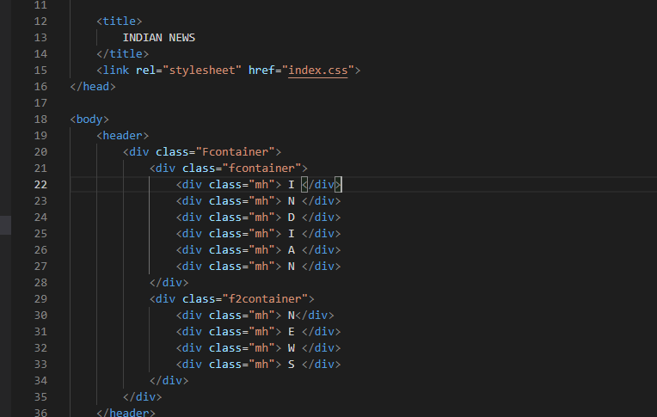

* Next, we created a navigation bar by the use of classes and hyperlinks to other pages.

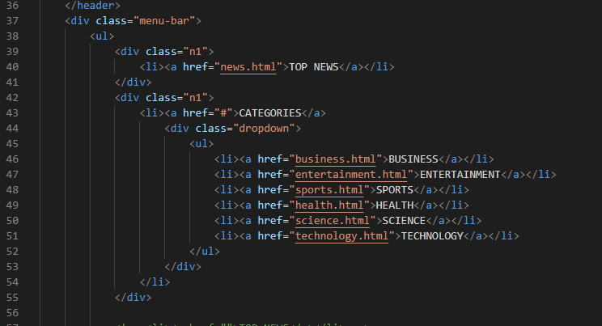

* We also used cards to display various categories of the news types with an image and description and also having hyperlink to the news section page

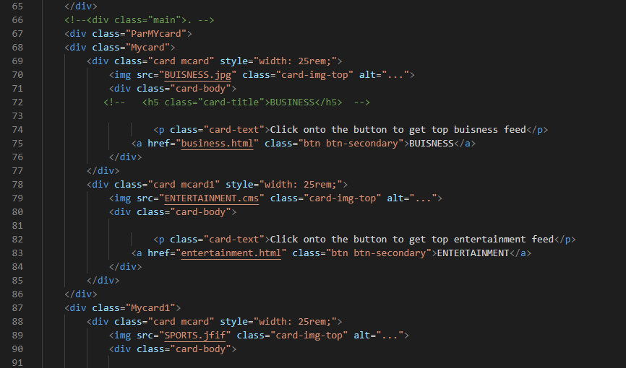.

**CSS:**

* Cascading Style Sheets or CSS is a language of style rules for html page.
* This programming language dictates how the html elements of a website should appear at the front end of the page.
* This is simple to use. This page used CSS for styling the home page where we required various images and header to styled.
* CSS is designed to enable the separation of presentation and content, including layout, colours, and fonts.
* We used CSS in this website to style various parts of our website. Firstly, we styled our header with an image and our title.
* Background image styling and title styling:

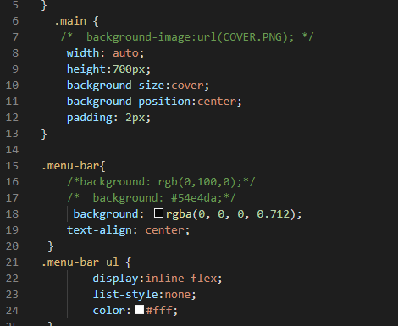

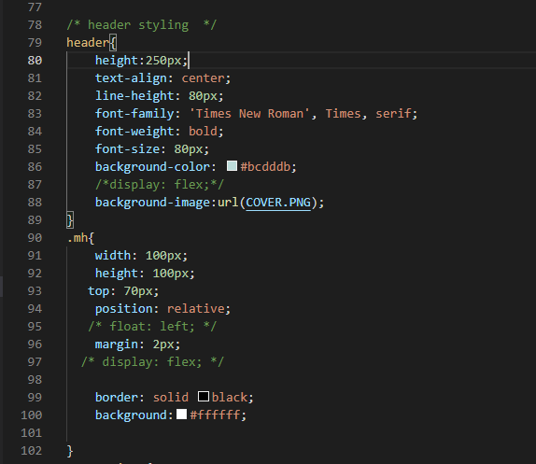

* Next, we used it to style our cards which represent our categories.

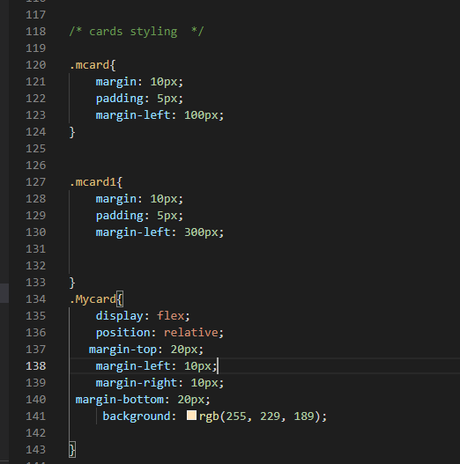

**JAVASCRIPT**

* JavaScript is programming language that can add interactivity to our website.
* JavaScript improves the user experience of the web page by converting it from a static page into an interactive one.
* This a linked to a html page and various functions are implemented.
* In our website we used JavaScript to populate our accordion or news containers with live news fetched from news API.
* This was also done using XHR requests (XML Http requests) which are objects used to interact with servers.  Retrieval of data from XHR for the purpose of continually modifying a loaded web page is the underlying concept of Ajax design.

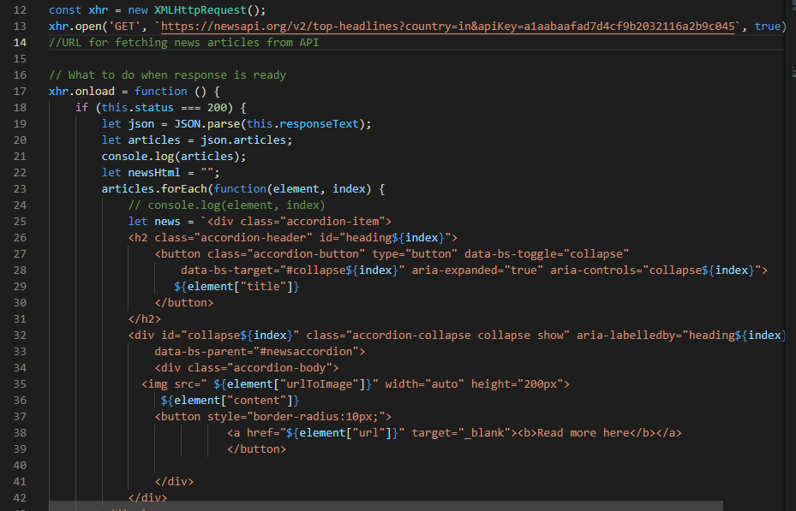

* Next, we also used JS to implement a keyword-based search engine which gives news articles related to user’s interested topics.
* This was implanted using JavaScript functions which on every click take a fresh search request and take users input to a variable and place in it the URL for fetching it from API.

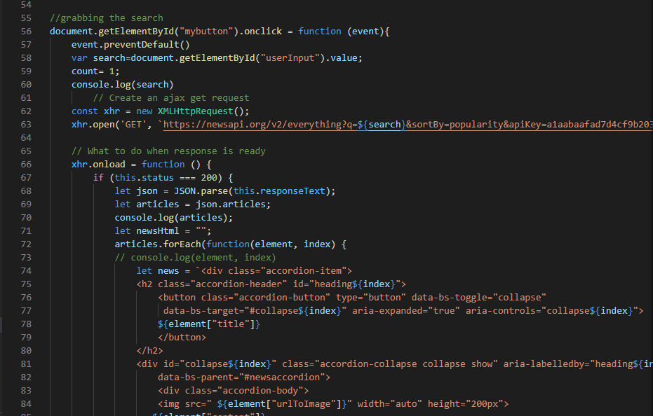

**Bootstrap**

* Bootstrap is a [free and open-source](https://en.wikipedia.org/wiki/Free_and_open-source) [CSS framework](https://en.wikipedia.org/wiki/CSS_framework) directed at responsive, [mobile-first](https://en.wikipedia.org/wiki/Responsive_web_design#Mobile_first,_unobtrusive_JavaScript,_and_progressive_enhancement) [front-end web development](https://en.wikipedia.org/wiki/Front-end_web_development). It contains [CSS](https://en.wikipedia.org/wiki/CSS)- and (optionally) [JavaScript](https://en.wikipedia.org/wiki/JavaScript)-based design templates for [typography](https://en.wikipedia.org/wiki/Web_design#Typography), [forms](https://en.wikipedia.org/wiki/Form_(HTML)), [buttons](https://en.wikipedia.org/wiki/Button_(computing)#HTML), [navigation](https://en.wikipedia.org/wiki/Web_navigation#Local_website_navigation), and other interface components.
* We used it create Navigation bar for every page of the website.
* We used bootstrap in various parts of our page to make it more attractive like in accordion which displays the news with title and collapsible container with description and image related to article.

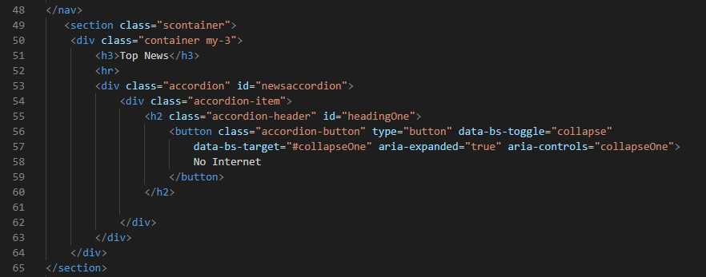

**API**

* API aka Application Program Interface which is a software intermediary that allows two applications to talk to each other.
* When you use an application on your mobile phone, the application connects to the Internet and sends data to a server. The server then retrieves that data, interprets it, performs the necessary actions and sends it back to your phone. The application then interprets that data and presents you with the information you wanted in a readable way. This is what an API is - all of this happens via API.
* APIs are a simplified way to connect your own infrastructure through cloud-native app development, but they also allow you to share your data with customers and other external users.
* Public APIs represent unique business value because they can simplify and expand how you connect with your partners, as well as potentially monetize your data (the Google Maps API is a popular example).

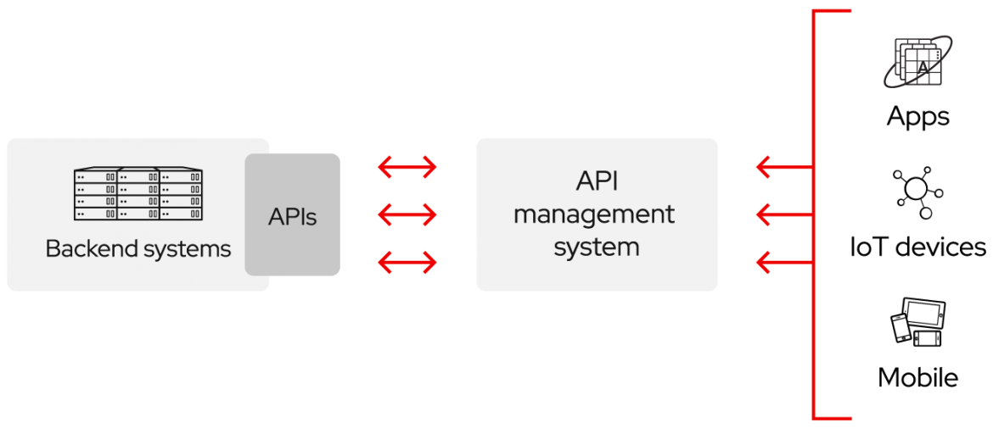

* This is the main part of our website as it serves as backend for our website.
* We used a public API for this website which is NEWS API from <https://newsapi.org/> which offers API key free of cost to registered users.
* We created our API key and used to create a URL link which retrieves data from servers using this API key.
* News API is a simple HTTP REST API for searching and retrieving live articles from all over the web.
* The main use of News API is to search through every article published by over 80,000 news sources and blogs in the last 4 years.
* The API returns with following data from the serves:

1. Author,
2. Content or title
3. Description
4. published data and time
5. Title
6. URL- to the articles to view full article on user’s interest.
7. URL to image- an image related to the news articles or present in it.

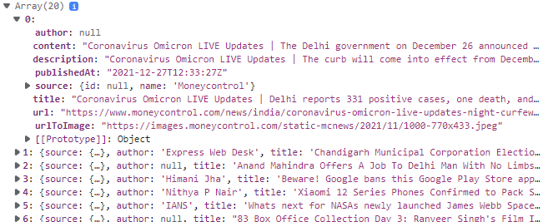

* The news API has various functions as in like firstly, we used it to get current top headlines of a country, category or publishers.
* We displayed 6 categories of news using this API which are : Business, Sports, Health, Technology, Entertainment, Science.
* We also used it to search articles from the servers which made our keyword-based search engine.

**VS CODE:**

* VS code is a code editor redefined and optimized for building and debugging modern web and cloud applications.
* We collectively implemented all of the above languages using a platform called VS Code.